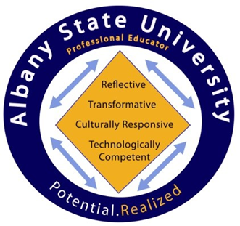

1. Reflective Practitioner:
1a. Professional Knowledge - The candidate demonstrates an understanding of the curriculum, subject content, pedagogical knowledge, and the needs of students by providing relevant learning experiences.
1b. Assessment Uses - The candidate systematically gathers, analyzes, and uses relevant data to measure student progress, to inform instructional content and delivery methods, and to provide timely and constructive feedback to both students and parents.
1c. Communication - The candidate communicates effectively with students, parents or guardians, district and school personnel, and other stakeholders in ways that enhance student learning.

2. Transformative Practitioner:
2a. Instructional Strategies - The candidate promotes student learning by using research based instructional strategies relevant to the content area to engage students in active learning and to promote key skills.
2b. Assessment Strategies - The candidate systematically chooses a variety of diagnostic, formative, and summative assessment strategies and instruments that are valid and appropriate for the content and student population
2c. Academically Challenging Environment - The candidate creates a student-centered, academic environment in which teaching and learning occur at high levels and students are self-directed learners.

3. Culturally-responsive Practitioner:
3a. Instructional Planning - The candidate plans using national, state and local school district curricula and standards, effective strategies resources, and data to address the differentiated needs of all students.
3b. Differentiated Instruction - The candidate challenges students by providing appropriate content and developing skills which address individual learning differences.
3c. Positive Learning Environment - The candidate provides a well-managed safe, orderly environment that is conducive to learning and encourages respect for all.
3d. Professionalism - The candidate demonstrates a commitment to professional ethics and the school’s mission, participates in professional growth opportunities, and contributes to the profession.
4. Technologically-Competent Practitioner:
4a. Integration – The candidate demonstrates understanding and the ability to integrate technology into curricula and administrative routines.
4b. Usage - The candidate demonstrates understanding and the ability to use multimedia tools and applications to conduct research and analyze data.
4c. Application - The candidate demonstrates understanding and the ability to apply technology in the teaching and learning process, collaborating and networking with colleagues to enhance professional

